Notes

1. Launch Outlook

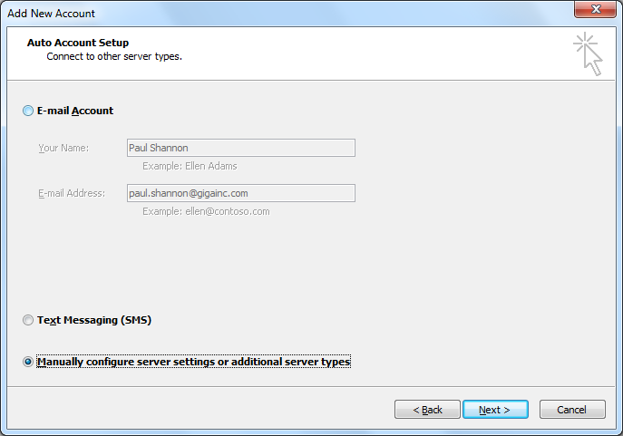

1. Next -> Internet Email

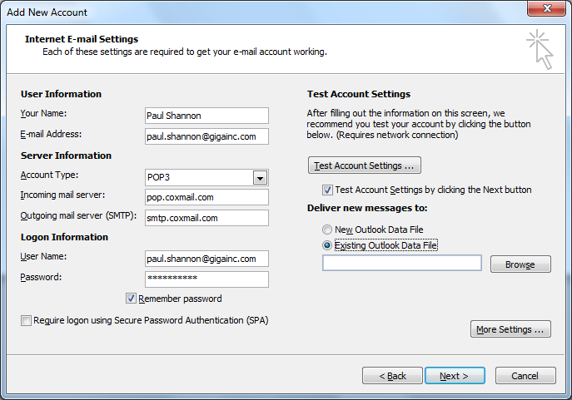

1. Use password from coxmail on X drive
2. Existing Outlook file
3. New folder – GIGA Employees
4. Import from GIGA Mail Employee List
5. Right-click -> Properties

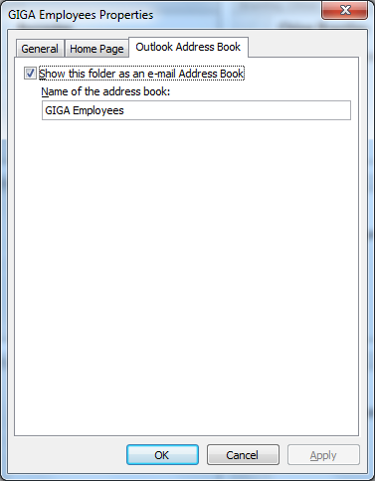

1. Address Book -> Tools -> Options
2. Custom -> Put GIGA Employees first
3. Open GIGA Employees first

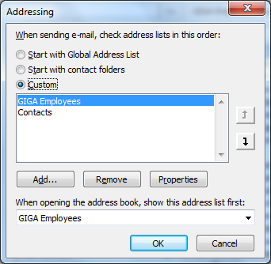

1. Remove mobile address book